|  |  |
| --- | --- |
|  |  |
| David A.W.A.M. Jansen  PhD student  Phone: +41 44 635 52 81  david.jansen@ieu.uzh.ch |
|  |
| Zurich, November 13, 2012 | |

MS: 3399353257711615 - Revised for BMC Biology

Segmental concatenation of individual signatures and context cues in banded mongoose (Mungos mungo) close calls

David A.W.A.M. Jansen, Michael A. Cant and Marta B.

Dear editor,

We would like to submit our revised manuscript “Segmental concatenation of individual signatures and context cues in banded mongoose (*Mungos mungo*) close calls” by David A.W.A.M. Jansen, Michael A. Cant, and Marta B. Manser for publication as research paper in BMC Biology.

We have integrated the suggestions, and added some key papers. The part on signatures versus cues is emphasized and we hope it is now clarified. Additionally, the whole paper has been re-read by all authors to remove any remaining errors.

We apologise for the misunderstanding on our part about the reviewers’ suggestions for additional spectrograms. We thank the 5th reviewer for the clarification and we have created a new figure with spectrograms of multiple individuals. We hope the resolution of the spectrogram is now of sufficient quality. Please see reply to reviewer 5 for details.

Finally, we are happy to provide the raw data of our study. We have uploaded our call recordings to the LabArchives repository, We have added references to this in the manuscript.

We think that the manuscript has improved by these revisions and we hope that you will find it suitable for publication in BMC Biology. Our responses to the additional comments of the 5th reviewer are outlined in detail on the following pages.

Sincerely yours,

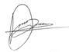

David A.W.A.M. Jansen*, Michael A. Cant, and Marta B. Manser

\**Corresponding author: David A.W.A.M. Jansen; Animal behaviour, Institute of Evolutionary Biology and Environmental Studies, University of Zurich, Winterthurerstrasse 190, 8057 Zurich, Switzerland.*

*Phone: +41446355281, fax: +41446355490, email:* [*david.awam.jansen@gmail.com*](mailto:david.awam.jansen@gmail.com)

*Queries/critiques are numbered and in red, italic font.*

Responses follow in black font. We have also indicated on which page (P) and/or lines (L) changes have been made.

Response to additional comments of reviewer #5

Most obvious is that the authors apparently did not understand the request for a new Figure 1: the idea is for a 3x3 grid of nine spectrograms where, for example, call contexts are in the rows and different individuals are in the columns. This would clearly illustrate the overall point of the manuscript, even if not all contexts and not all individuals are presented. Note that the quality of the current submitted spectrogram is also inadequate: these need to be publication-quality spectrograms (e.g. generated by Praat).

We apologise for misunderstanding this request.. We recognize the improvement the 3x3 spectrogram would give. We have created a new high resolution Figure 1 as suggested, and amended the figure legend as necessary.(Figure 1 and P17 L3-9). The new figure is shown below.

We hope the spectrogram is now of sufficient quality. We attempted to increase the resolution further but this was not possible. We contacted Avisoft about this and got the reply below.

*That spectrogram image has already a relatively high resolution. You might*

*only further increase the temporal resolution by increasing the overlap. The final resolution on the printed publication (expressed in dots per inch*

*“dpi”) will depend on the scaling of the digital image (making the image*

*smaller on the print page will increase the absolute dpi value).*

*There is however currently no way to further increase the frequency axis*

*resolution beyond 512 pixels (half of the FFT length). I do believe that*

*this resolution is sufficient for a greyscale spectrogram image on a printed publication.*

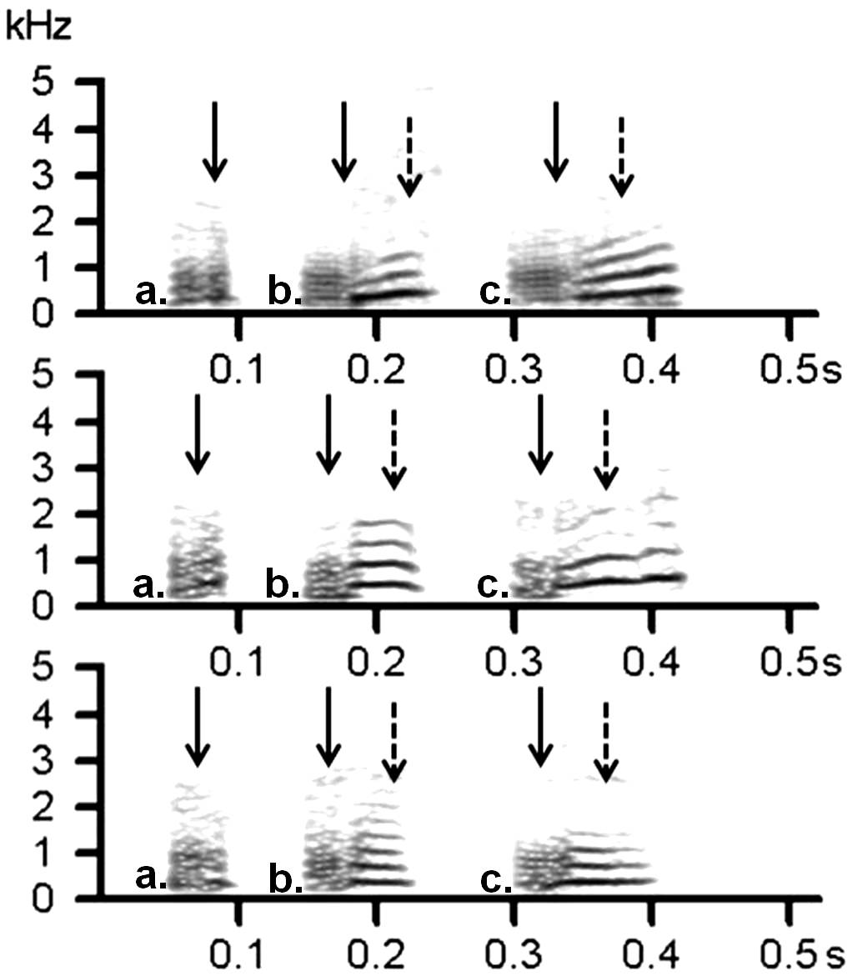

Second, the terminology differentiating cues versus signatures remains somewhat unclear and seems to have been inconsistently implemented. Again a slow, careful, re-reading and edit is required.

We have changed the text where we introduce the signatures and cues (P3 L5-8). We thereafter consistently refer to vocal signatures and vocal cues as vocal cues.

Third, while the addition of the discussion of acoustic cues, and the new references quoted, make a good start, this remains incomplete. Several of the cited papers (and many others that are not quoted) focus on the importance of formant frequencies, and one of the main obsessions in this literature has been with cues to body size. Neither of these is currently mentioned.

As suggested, we have included reference to several key papers concerning cues to body size. We originally left out any reference to formants because to our knowledge they have not been shown to be applicable for smaller species like the banded mongooses. However we recognize that referring to these studies broadens the perspective of our work. We have therefore also included a small session on formants (P3 L13-16).

Fourth, the reference list, besides being rife with typos, is not fully satisfactory, and one has the feeling that whatever references popped quickly to mind are cited. To cite two examples, acoustic cues in deer vocalizations are mentioned, but the comprehensive work of Reby and colleagues is not cited (this predates, and is much broader, than the quoted Briefer et al (2010) study), nor is the classic paper of Clutton-Brock and Albon cited in this context. For primates, the initial study showing formant/size correlations should be cited (Fitch 1997) in addition to the current (Fischer/Owren) citations.

We have corrected the typographic errors. We refer to the Briefer et al 2010 paper, because it specifically deals with the trade-off between multiple vocal cues (P3 L29 and thereafter). However, we acknowledge that the work of Reby et al and Clutton-Brock & Albon are key papers in this field. We have therefore added these references when we refer to male quality (P3 L10) .

Fifth, the authors write "physical characteristics that determine vocal characteristics of an individual (e.g. larynx length)". To my knowledge the length of the larynx is irrelevant to any measurable acoustic cue: this should be either (or both): vocal fold length (for F0), or vocal tract length (for formants).

We thank the reviewer for this clarification and have changed the text accordingly (P6. L17.)

Regarding the very first sentence "Most animals are anatomically constrained in the number of discrete call types they can produce.". "Most" connotes "not all", but the statement is logically true for any species (including humans, as the authors note in their response to reviewers). This should be rewritten as "All animals are anatomically constrained in the number of discrete call types they can produce and perceive"

We agree with this comment and have changed the sentence in the abstract. (P2 L2)

Further typos (NOT complete, just a selection):

being individually, distinct - excess comma our findings maynot unique to banded mongooses.

evidence of Marler?s hypothesis - evidence supporting Marler's hypothesis likely q common but so far neglected dimension -- missing comma Although, this principle was already proposed - excess comma While in some species? contact calls seem to function on mid- to long-distances, -- apostrophe should be comma, "function on" should be "function over".

cetacean spp. -- should be cetacean species (abbreviation spp. is only used after a genus name) single syllable close call "mimics this system" -- "is analogous to this system"

decoded by listeners [3,3,4,58?63] - 3 repeated frequency of fundamental frequency -- double use "frequency" unnecessary, just say fundamental frequency

We have corrected the mistakes above and thoroughly checked the whole paper.

Wrong references:

Capitalization and punctuation is inconsistent throughout.

Many of the references have middle initials (as they should, e.g. 6, 7, 11, 15) but many, perhaps most, lack them (e.g., 1, 5, 12, 18, 50), or lack any first name at all, or get the name wrong (e.g., 21, 48, 69). This is NOT an exhaustive list of errors, just ones I caught at first glance.

We have gone through all the references and corrected mistakes in the bibliography file. We have used the BMC latex bibliography file to ensure correct layout of references.